Practice Leaflet 2025

A Guide to our services

Albrighton Medical Practice

Shaw Lane

Albrighton

Wolverhampton

WV7 3DT

Tel. 01902 372301

www.albrightonmedicalpractice.nhs.uk

**WELCOME**

Albrighton Medical Practice welcomes you to the Surgery and we hope that you find the enclosed information useful. More information is available on our website; [www.albrightonmedicalpractice.nhs.uk](https://www.albrightonmedicalpractice.nhs.uk)

###### **Opening Hours:**

###### The surgery is open 8.00 am to 6.00 pm Monday to Friday (excluding bank holidays).

Extended opening hours are provided on Monday evenings 6.30pm to 8.30 pm. These are for booked appointments only. No emergency provision is available during this time at the surgery.

The Surgery is open every fourth Saturday for pre booked appointments, no emergency provision is available on a Saturday morning.

**Call 999 in a medical or mental health emergency. This is when someone is seriously ill or injured and their life is at risk.**

**If you need help when we are closed**

**If you become ill and your GP surgery is closed, there are several options available to you (Pharmacy First, NHS walk in centre, Minor injury Units, Urgent treatment centres – please look at our website for further information)**

###### **NHS 111 (please telephone 111) provides out of hours cover to our patients. NHS 111, tel. 111, or NHS Choices www.nhs.uk, provides health information 24 hours a day. You can also attend**

###### We are a medical partnership providing services for

###### Shropshire, Telford & Wrekin ICS, Wellington Civic Offices, Larkin Way, Tan Bank, Wellington, Telford, TF1 1LX.   Email: [stw.generalenquiries@nhs.net](mailto:stw.generalenquiries@nhs.net)

###### Details of primary medical services in our area may be obtained from them.

###### We are additionally, a part of the [Southeast Shropshire Primary Care Network](https://seshropshirepcn.com/).

###### A Primary Care Network is a structure which brings together GP Practices in an area. PCNs build on existing primary care services and enable greater provision of proactive, personalised, coordinated and more integrated health and social care for people close to home.

**The Practice Team**

**Practice Manager -** Mrs. Bridget Laffoley

**Partners**

**Dr Annette Quilter** MBChB (Birmingham 2008), MRCGP, DRCOG, DFRSH

**Dr Prabhjot Uppal** MBBS (2000), DRCOG, MRCGP, DFSRH

**Dr Clare Hurst** BSc, MBChB, MRCGP, MSc

**Dr Emily Ward** MBChB, MRCGP, DRCOG

**Dr Matthew Bird** MBChB (Birmingham 1999), MRCGP, MRCS (Edinburgh), DCH, DRCOG, DFFP

**Salaried GPs**

**Dr Jessica Harvey** MRCGP, MBBS, BSc Hons

**Dr Margaret Mascarenhas** MBChB with Honours (Birmingham 2011), MRCGP, MRes, BSc with First Class Honours, DRCOG, PGCert

**Dr Rupinder Bhandal** MBChB, MRCGP, DRCOG

**Dr. Onyinye Claire Ibekwe** MBBS, MRCGP

**Nursing Team**

**Practice Nurses** Lindsey Harris, Hayley Avery, Rebecca Podmore.

**Nurse Associate** Sue Mumford,

**Health Care Assistants** Tracey Gamble, Meegan Webb.

**Reception Team**

**Admin Team**

**Dispensers**

**Community Care Coordinator**

**ARRS staff -** Physician Associate, Clinicial Pharmacists, First Contact Physiotherapist, Healthy lives advisor

**Training Practice -** We are proud to be a training practice, helping to develop healthcare professionals of the future. Being a training practice allows us to reflect on our our knowledge, skills and performance. We have medical students from Keele University and also GP Registrars during their training. Each trainee receives appropriate levels of supervision. You maybe be offered an appointment with a trainee, you will always have the opportunity to decline this if you do not feel it is appropriate for you.

**Appointments**

We want to make the process of booking an appointment with your GP practice as easy and fair as possible. We use a system called AccuRx Total Triage

**How do I contact the practice/request an appointment?**

Online request - this is the preferred method, you can still contact the surgery by telephone (01902 372301) or in person and Reception will help you. Accurx Total Triage is our online consultation platform accessible via NHS App or clicking on the link on our website. It removes the need to hang on the telephone and avoids the 8 am rush.

**What happens to my request?**

Medical requests are triaged by a GP, who will decide on the most appropriate action and timescale, which may include, telephone or face to face appointment, advice or signposting to another service.

Medical requests we will respond to you the same day

Admin requests are viewed and directed to the most appropriate team member for action, we will respond to you within five working days.

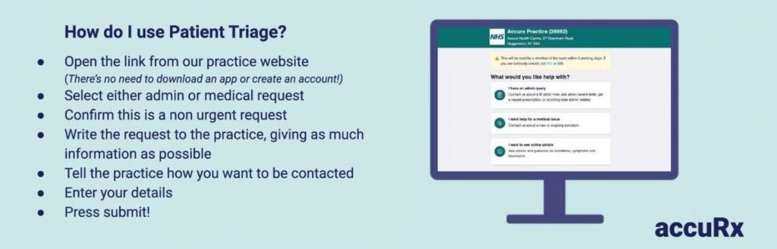

**Text Messages**

Please be aware we may contact you by secure text message in response to your request, to remind you about appointments or provide health information (such as upcoming flu vaccinations).

**Prescriptions**

The easiest way to order your repeat prescription is by using the [NHS App](https://www.nhs.uk/nhs-app/), this shows you all your repeat medicine and dosages and you can choose the ones you need.

Alternatively you can request your prescriptions using;

[Prescription Ordering Direct (POD) service - NHS Shropshire, Telford and Wrekin](https://www.shropshiretelfordandwrekin.nhs.uk/your-health/where-to-get-advice-and-help/prescription-ordering-service/)

The POD can be contacted via telephone on 0333 358 3509, Monday to Friday between 9am and 5pm. It is a large call centre with 30+ handlers to deal with your request. They can also be contacted using their form or by email [shropshire.pod@nhs.net](mailto:to shropshire.pod@nhs.net)

*Please note: we do not take repeat prescription requests over the phone or email.*

**Dispensing Patient Prescriptions**

We are fortunate to have a Dispensary at the practice which means we can dispense medication to some of our patients. Legislation means that we can only dispense your medication is you live more than three miles (by road) from the chemists in Albrighton or Shifnal. The dispensary opening hours are: 08.30 to 6.00 pm daily.

If you are a dispensing patient you can use [NHS App](https://www.nhs.uk/nhs-app/) or [POD](https://www.shropshiretelfordandwrekin.nhs.uk/your-health/where-to-get-advice-and-help/prescription-ordering-service/) to request your repeat prescriptions or you can contact Dispensary by phone 01902 372301.

Home delivery of medications for dispensing patients can be arranged. Please contact dispensary if this service is required.

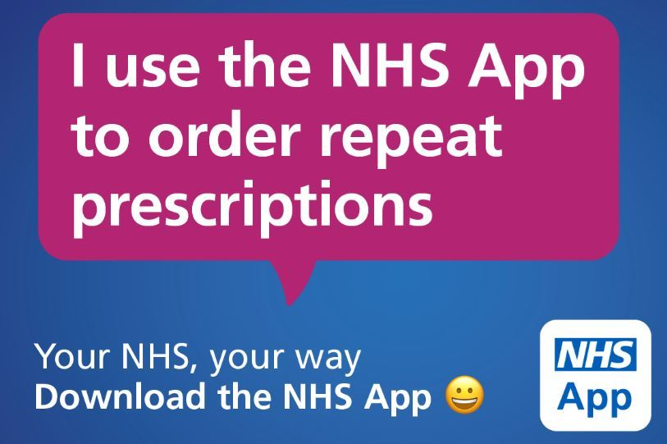

**Home Visits**

If you need to be seen but are unable to get to the surgery, you may request a home visit. Please contact the surgery **before 10.30 am.** Home visits will be attended to at lunchtime.

**Please Note:**Home visits are for the genuinely housebound, serious and terminally ill patients. Please do not abuse this service. Should you have difficulty getting to the surgery because of lack of transport, please consider using the the Flyer 07543 869754 (Melville Club Members) or contact the Community Car driving scheme 07506 057412.

Please be aware, if you are requesting a home visit we will only visit you at the address you are registered with at the practice. On no account are we able to provide a home visiting service outside of our practice area.

We regularly use the Urgent Community Response team (previously Rapid Response Team) who may visit on our behalf, it is often more appropriate that they do. They will see conditions that may warrant a hospital admission such as chest infection, urine infection, skin infections/cellulitis and falls in the home (not exhaustive). The team will advise that you may not be visited by a GP from the surgery and this is to ensure that we see all of our genuinely housebound in a timely manner whilst being able to see those we need to in the surgery too. If you wish to have more information about the Urgent Community Response team, please ask the reception team.

**Disabled Access**

Disabled access is via the front entrance. All clinical areas have disabled access.  If you have any special requirements please inform the reception staff.  We have a hearing loop for those that need it.

**Named GP**

As a Practice we are required to allocate all patients with a Named GP.

The named GP for newly registered patients will be the GP they are registered to.

This does not prevent any patient from seeing any GP within the practice or change the GP normal

**Registration**

Our practice covers a semi rural population including the villages of Albrighton, Pattingham, Badger, Beckbury, Tong, Tong Norton, Worfield, Chesterton and surrounding areas. A map is available on our website that shows detail of our practice boundary.

Anyone who lives within the practice boundary is allowed to register with the practice. Including the homeless and traveler communities. Patients wishing to register must attend the surgery and complete the appropriate form and present valid proof of address (if you have one available) or in the case of a new born baby the form issued by the registrar of births and deaths.

Once registered, should you move to a location that is outside the practice boundary you will be required to register with a new surgery. You will not be permitted to remain on our list of patients.

It is the responsibility of the patient or the guardian of the patient to inform the surgery should any changes take place that could affect their medical care. In particular address and telephone number changes, also changes from maiden to married names.

Patients are registered with the practice and not individual doctors. It is fine to request an appointment with a particular doctor for continuity of care or patient choice.

As patients we would request that you consider your own rights and responsibilities to the surgery especially with regard to missing appointments.

**Change of address/practice boundary**

If you are thinking of moving house please check our website/speak to reception to find out if your new address is in our area. If your new address is outside of our area you will need to register with a new GP practice.

Please remember to let us know of any changes to contact details as soon as possible.

# Complaints / Feedback

# We make every effort to give the best service possible to everyone who attends our practice. However, we are aware that things can go wrong resulting in a patient feeling that they have a genuine cause for complaint. To pursue a complaint please contact the practice manager who will deal with your concerns appropriately.Our Complaints protocol is on our website.

# We also welcome feedback both positive and negative. You give feedback directly, on our website or via the NHS friends and family test. More information on our website.

# Services

The practice offers the following services to its patients in addition to standard GP services.

Antenatal

Blood tests

Cervical Screening

Citizens Advice Bureau

Community Care Coordinator

Contraception

Ear Irrigation

Immunisations

Joint Injections

Minor Surgery

Talking therapies

Young Persons

# Non NHS Work

We will also be happy to provide non-NHS work including medicals

(e.g. HGV medicals), private sick notes and holiday travel insurance forms. A fee will be charged and payment is required before the work is carried out. Reception Staff will advise you what the fee will be. The fee will be subject to VAT.

**Travel Health**

If you require NHS travel vaccinations, we are happy to provide these. However, we are unable to give travel advice.

If you are travelling please attend a private travel clinic and take with you a copy of your vaccination history. We can provide a list of your previous vaccinations or this can be found on your NHS App. If you then require NHS vaccinations we ask that you provide documentation from the travel clinic you have attended, we need to have this two weeks before any vaccines can be administered. The nursing team need to review the request and order in the required vaccines. Please book an appointment with the practice nurse two weeks after providing your travel clinic documentation.

**Your Data**

Your GP Practice is committed to operating in a way that complies fully with the provisions of the General Data Protection Regulation (GDPR) and the Data Protection Act 2018. We recognise that the personal data legitimately required in order to carry out our business must be collected, processed, stored and disposed of fairly, lawfully and with due regard to confidentiality. We fully respect your privacy.

If you have any questions about your data or how we deal with it please contact the practice and get in touch with us by clicking on the Contact Us links available on this website.

**Accessible Information / Reasonable adjustment flag**

We want to get better at communicating with our patients. We want to make sure you can read and understand the information we send you. If you find it hard to read our letters or if you need someone to support you at appointments, please let us know.

*The Reasonable Adjustment Flag is a national record that shows a person needs accommodations and may include details about their impairments and necessary adjustments.*

**If you are a patient or carer of a patient who you feel may benefit from a Reasonable Adjustment Flag on your medical records please let a member of the practice team know. We will not add a Reasonable Adjustment Flag to your record without your consent.**

This practice leaflet provides a brief overview of the practice only, for more detailed information please consult our website [www.albrightonmedicalpractice.nhs.uk](https://www.albrightonmedicalpractice.nhs.uk).

On the website you will find our surgery policies and procedures.

If you do not have internet access we are happy to print this information off for you.